Experiment 2

Aim: Data Profiling, Cleaning & Feature Engineering

Objective
The objective of this experiment is to perform comprehensive data profiling and preprocessing on the acquired student performance datasets in order to improve data quality and prepare them for machine learning. The experiment involves analysing the datasets for missing values, duplicate records, inconsistent data types, and potential outliers, followed by appropriate cleaning and transformation procedures. New informative features are engineered to better represent the underlying characteristics of student performance. The processed dataset is then validated using a schema validation framework to ensure consistency and reliability before being versioned using DVC, thereby maintaining a reproducible data processing pipeline.

Problem Statement
Raw datasets collected from open data repositories often contain inconsistencies such as missing values, duplicate records, inconsistent formatting, and irrelevant attributes that can negatively affect the performance of predictive machine learning models. In educational datasets, incomplete attendance records, inconsistent categorical values, and data entry errors may reduce model accuracy and introduce bias into the learning process.
Before any predictive modelling can be performed, it is therefore necessary to profile the data to understand its quality, clean any identified issues, engineer meaningful features that better represent student behaviour, and validate the processed dataset to ensure it satisfies predefined quality requirements. A structured and reproducible preprocessing workflow also ensures that future experiments operate on reliable and consistent data.
This experiment focuses on transforming the raw student performance datasets obtained in Experiment 1 into a high-quality analytical dataset suitable for subsequent machine learning experiments.
Data Profiling
Data profiling was performed to gain a detailed understanding of the structure and quality of the acquired datasets before any preprocessing operations were carried out. A comprehensive profiling report was generated using the Pandas Profiling library, which automatically analysed every feature within the datasets and produced detailed statistics describing data completeness, distributions, correlations, missing values, duplicate records, and potential anomalies.
The profiling report provided an overview of the total number of observations, the number of variables, memory usage, data types, unique values, descriptive statistics for numerical features, frequency distributions for categorical features, and warnings regarding data quality issues. Particular attention was given to identifying missing values, duplicate entries, skewed distributions, high-cardinality categorical attributes, and potential outliers that could influence predictive modelling.
The profiling stage served as the foundation for all subsequent cleaning and feature engineering activities by highlighting areas requiring preprocessing.
[Dataset Loaded into Notebook]
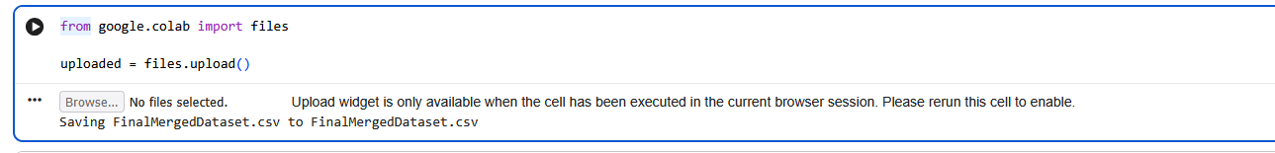
[Pandas Profiling Report Generated]
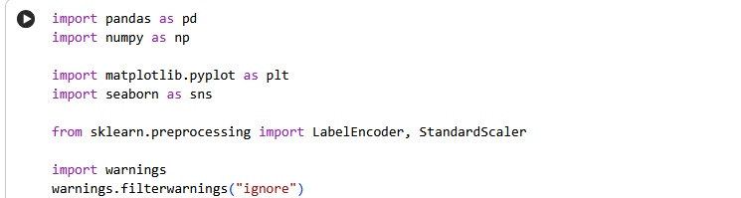
[Dataset Overview]
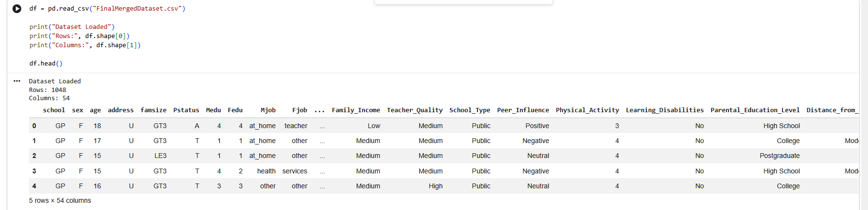
[Missing Values Summary]
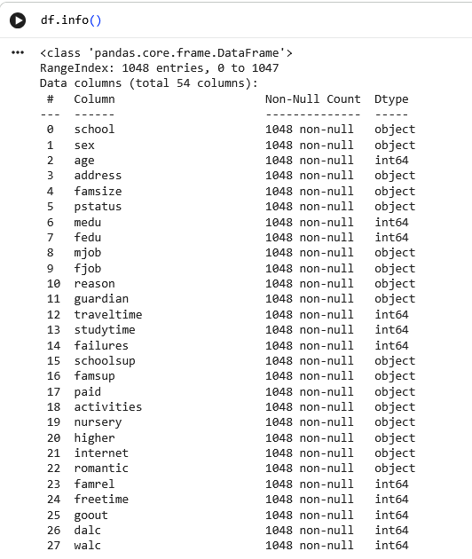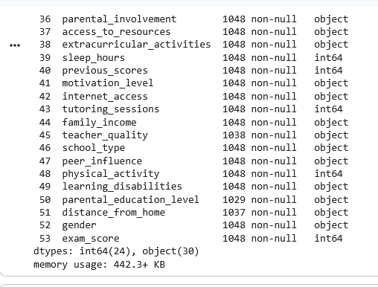
[Correlation Analysis]
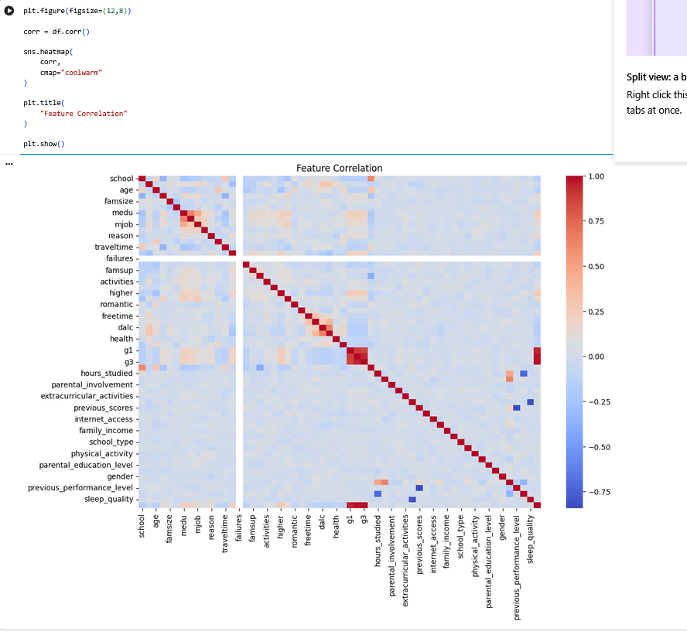
Handling outliers
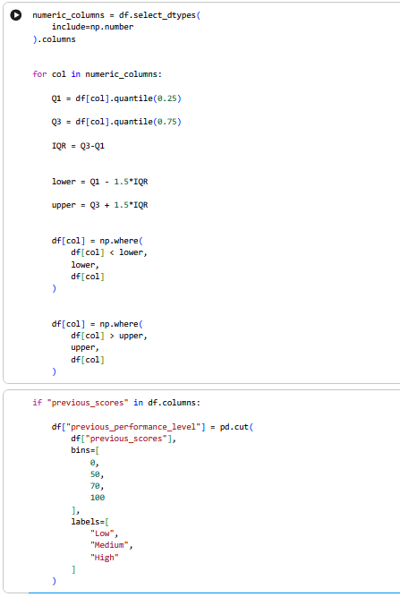

Cleaning Missing Values and Duplicate Records
Based on the profiling results, the datasets were carefully cleaned to improve overall quality and consistency. Missing values were analysed individually for each attribute before selecting the most appropriate treatment strategy. Numerical variables with missing observations were completed using suitable statistical measures where appropriate, while categorical attributes were standardised and completed using the most representative category whenever feasible. Columns containing insignificant or unnecessary information were reviewed and retained only when relevant to later predictive analysis.
Duplicate records were then identified across the datasets to ensure that no student observations were repeated. Duplicate entries were removed so that every record represented a unique student instance. This step prevents duplicated information from introducing bias into model training and evaluation.
Data types were also verified to ensure that numerical variables were stored in appropriate numeric formats while categorical attributes remained properly encoded as text variables. Inconsistent formatting, whitespace issues, and categorical value inconsistencies were corrected to improve dataset uniformity.
Following these preprocessing operations, the cleaned datasets contained consistent, complete, and well-structured records suitable for further analysis.
[Missing Values Before Cleaning and Missing Values After Cleaning]
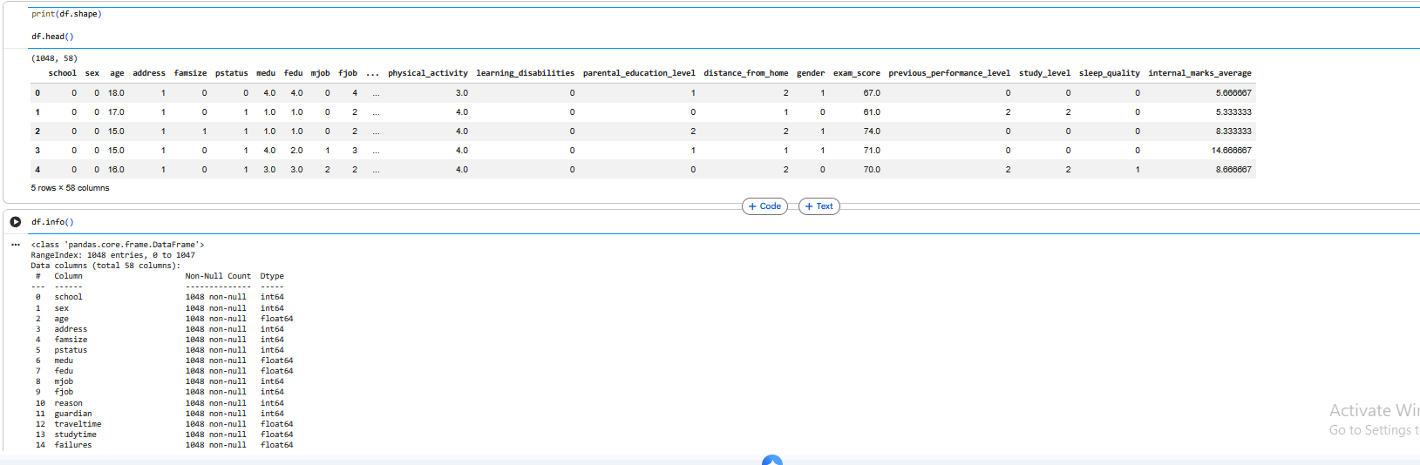
[Duplicate Records Removed]
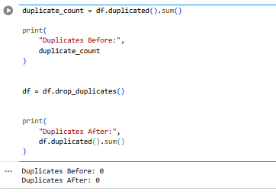
[Updated Dataset Summary]

Feature Engineering
After the datasets had been cleaned, additional features were engineered to improve the predictive capability of future machine learning models. Feature engineering transforms existing variables into more informative representations that better capture student learning behaviour and academic performance patterns.
Several derived attributes were created from the existing information available within the datasets. Continuous numerical variables were grouped into meaningful categories where appropriate to simplify interpretation while preserving important trends. Attendance percentages, study habits, sleep duration, and other behavioural indicators were transformed into structured categories that better represent different levels of academic engagement.
Where applicable, binary indicator variables were introduced to represent meaningful student characteristics, allowing machine learning algorithms to distinguish important behavioural patterns more effectively. Feature engineering also included the creation of grouped performance indicators that summarise multiple related variables into more informative features while avoiding unnecessary redundancy.
These engineered variables provide richer information than the original raw attributes and are expected to improve prediction accuracy during later classification experiments.
Examples of Engineered Features
Original Feature | Engineered Feature | Purpose
Attendance Percentage | Attendance Category | Groups attendance into Low, Medium, and High participation levels.
Study Hours | Study Intensity | Categorises students according to daily study effort.
Sleep Hours | Sleep Quality Indicator | Represents healthy and unhealthy sleep patterns.
Previous Scores | Performance Category | Classifies historical academic performance into broader achievement groups.
Extracurricular Activities | Participation Flag | Indicates whether students actively participate in extracurricular activities.
[Feature Engineering Process]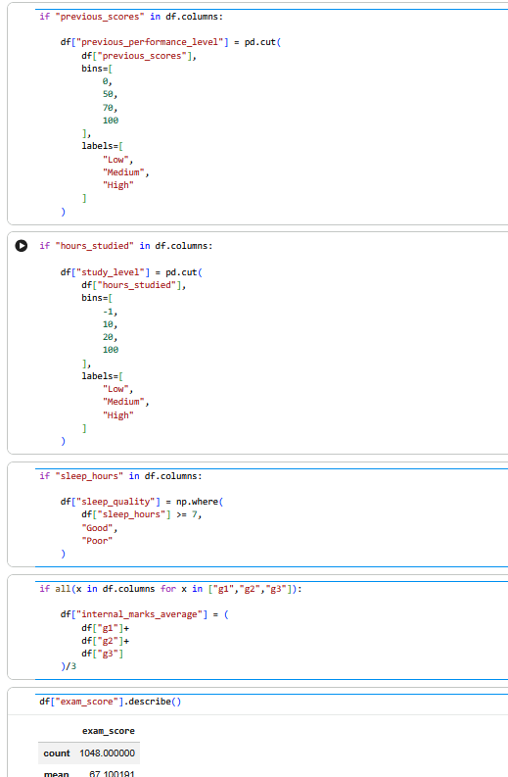
[New Features Added]
study_level
sleep_quality
internal_marks_average

[Updated Dataset Preview]
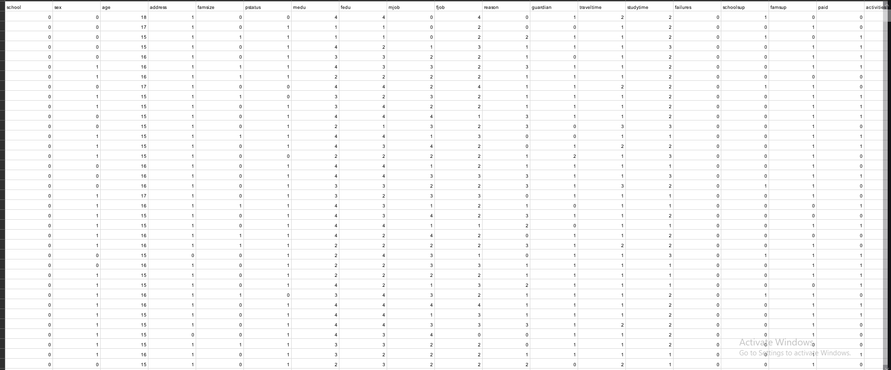
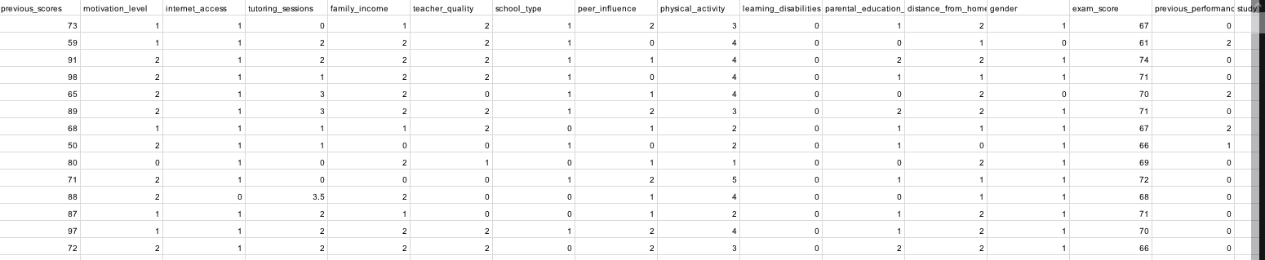

Dataset Validation using Great Expectations
Once preprocessing and feature engineering had been completed, the processed datasets were validated using the Great Expectations data validation framework. Validation ensures that the cleaned data satisfies predefined quality rules before it is used for machine learning.
An expectation suite was created to define the expected structure and quality constraints of the dataset. These validation rules verified that required columns were present, data types remained consistent, numerical attributes fell within acceptable ranges, missing values remained below acceptable thresholds, and categorical variables contained only valid values.
Validation also confirmed that duplicate records had been removed and that the engineered features satisfied the intended schema. The validation report documented the success or failure of each expectation, providing transparency and confidence that the processed dataset met all required quality standards.
By introducing automated validation into the preprocessing workflow, future modifications to the dataset can be verified quickly and consistently without requiring manual inspection.
[Validation Results]
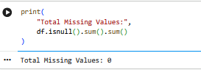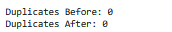

Versioning the Cleaned Dataset with DVC
After successful validation, the cleaned datasets were brought under Data Version Control (DVC) to preserve a reproducible record of all preprocessing activities. Unlike the raw datasets versioned during Experiment 1, this stage created a new version representing the fully cleaned and feature-engineered data.
The processed datasets were stored within the project's processed data directory and tracked separately from the original raw files. Updated DVC metadata files were generated to record the exact state of the processed datasets, while Git tracked the corresponding configuration files and metadata required to reproduce the preprocessing workflow.
The processed dataset version was then synchronised with the configured DVC remote storage, ensuring that both raw and cleaned versions remain permanently available and can be restored whenever necessary. This versioning strategy supports reproducible experimentation by allowing every subsequent machine learning model to reference the exact dataset version on which it was trained.
[Processed Dataset Saved]
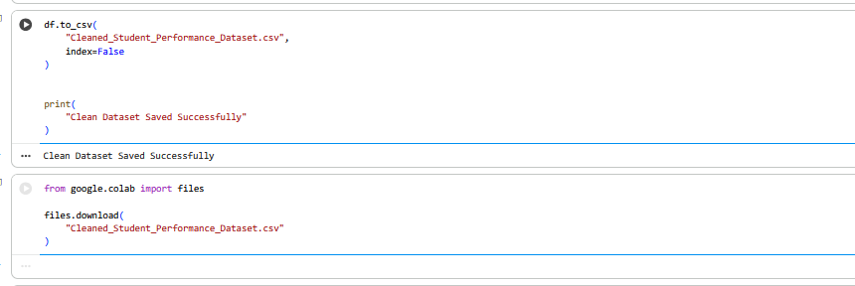
[DVC Tracking Updated]
[Git Commit for Cleaned Dataset]
[DVC Push Completed]

Success Metrics
The following metrics were used to evaluate the effectiveness of the data preprocessing and validation workflow.
Metric | Target Value | Purpose
Missing Values Remaining | 0% (or within acceptable limits) | Ensures that missing data has been successfully addressed.
Duplicate Records | 0 | Confirms that duplicate observations have been removed.
Schema Validation Success | 100% | Verifies that all validation rules pass successfully.
Feature Engineering Completion | 100% | Confirms that all planned derived features were successfully created.
Dataset Integrity | 100% | Ensures processed data remains consistent and reproducible.
DVC Versioning Success | 100% | Confirms successful tracking of the cleaned dataset.
Deliverables
The following outputs were produced during this experiment.
Deliverable | Description
Profiling Report | Comprehensive report describing dataset quality, distributions, missing values, correlations, and outliers.
Cleaned Dataset | Fully preprocessed dataset with missing values handled, duplicates removed, and consistent formatting applied.
Engineered Features | Additional variables created to improve predictive modelling performance.
Validation Suite | Great Expectations schema and validation report confirming dataset quality.
Versioned Dataset | Cleaned dataset tracked using DVC for reproducibility and future experiments.

Open-Source Tools
Tool | Purpose | Role in Experiment
Pandas | Data manipulation and preprocessing library. | Used for cleaning, transforming, and analysing the datasets.
PyJanitor | Data cleaning extension for Pandas. | Simplified preprocessing and dataset cleaning operations.
Pandas Profiling | Automated exploratory data analysis tool. | Generated comprehensive profiling reports highlighting data quality issues.
Great Expectations | Data validation framework. | Verified dataset schema, completeness, and quality constraints.
DVC | Data Version Control system. | Tracked and versioned the cleaned datasets.
Git | Distributed version control system. | Managed preprocessing scripts, notebooks, and DVC metadata files.
Jupyter Notebook | Interactive development environment. | Used for exploratory analysis, preprocessing, and documentation.

Conclusion
This experiment successfully transformed the raw student performance datasets into clean, validated, and feature-rich datasets suitable for predictive modelling. Comprehensive profiling identified potential quality issues, while preprocessing eliminated missing values, duplicate records, and inconsistencies. Additional features were engineered to better capture patterns associated with student performance, improving the analytical value of the datasets. Automated schema validation using Great Expectations ensured that the processed data satisfied predefined quality standards, and DVC maintained complete version control of the cleaned datasets. The resulting reproducible and validated dataset provides a reliable foundation for the machine learning model development and evaluation carried out in the subsequent experiments.

